Hero section

* [Online Dry Fruits Store in Pakistan — Dry Nut Store](https://drynutstore.com/)
* [Dry fruits Online Hyderabad |Dry Fruits Online Shopping Hyderabad India |Buy Online Best Dry Fruits in Hyderabad India |Wholesale Dry Fruits Online Hyderabad |Dry Fruits Online SameDay Delivery in Hyderabad India - DryfruitsJunction](https://dryfruitsjunction.in/)

Bestseller

* [minimarket](https://opencart.workdo.io/minimarket/)

Our Categories

* [NUTRAJ: Buy Dry Fruits Online from India's No.1 Dry Fruits Store](https://www.nutraj.com/)

People’s Choice

* [Buy Dry Fruits & Spices Online : Best Seller in India - MevaBite](https://www.mevabite.com/)

About Us

* [Online Dry Fruits Store in India, Buy Dry Fruits Online at Best Price.](https://www.navkaardryfruits.com/)

Product Details

* [theme848-spices-store](https://theme848-spices-store.myshopify.com/)

Quick Buy Section

* [Mavuno Harvest | Organic Dried Fruit, Nuts & Fruit Bites](https://mavunoharvest.com/)

Products comparisons

* [gbdryfruitsupplier.pk](https://gbdryfruitsupplier.pk/)
* [Compa re](https://gbdryfruitsupplier.pk/compare/)

Clients Review

Bets Seller Product

* [Premium Dry Fruits and Nuts: Your One-Stop Online Store For Healthy Snacking | TRV Cashews](https://trvcashews.com/)

Instagram Feed

* [Luxury Dry Fruits, Nuts and Dates Gifts For Corporate and Personal – Ajfan Store](https://ajfan.store/)

You me also like

* [Buy Premium Dry Fruits, Nuts, Seeds and Berries Online in India](https://happilo.com/)

Active Trades

* [Mega Grain – Trusted agri-commodity brokerage firm, deals in cerealsand grains, pulses, spices etc.](https://www.megagrain.com/)

Top **Dry Fruits** Wholesale in India

* [Dry Fruits Wholesaler in Delhi, India - Bulk Deals & Discounts](https://surbhidryfruits.com/)

Reference

* [Zoff Foods : Buy Indian Spices From Online Spices Store](https://zofffoods.com/)

********************************************************

Nave Bar

[Travel Agency Website Design To Ignite The Wanderlust 🌎✈ by Excellent Webworld on Dribbble](https://dribbble.com/shots/21290124-Travel-Agency-Website-Design-To-Ignite-The-Wanderlust)

For Hero section

[Dribbble - Restaurant Landing.jpg by Nasim ⛹🏻‍♂️](https://dribbble.com/shots/15785732-Restaurant-Landing-Page-Bites/attachments/7594368?mode=media)

[Dribbble - nuts.png by Product Designer](https://dribbble.com/shots/11547966--Almond-Oil-Nuts-Ecommerce-Web-Design/attachments/3168661?mode=media)

Category section

[Summer Camp website Header :: Behance](https://www.behance.net/gallery/211557217/Summer-Camp-website-Header?tracking_source=search_projects|category+design+header+website&l=0)

[Eatly Landing Page design :: Behance](https://www.behance.net/gallery/136232057/Eatly-Landing-Page-design)

[Travel Agency Website Design To Ignite The Wanderlust 🌎✈ by Excellent Webworld on Dribbble](https://dribbble.com/shots/21290124-Travel-Agency-Website-Design-To-Ignite-The-Wanderlust)

[GoFishing / GoHunting :: Behance](https://www.behance.net/gallery/11558161/GoFishing-GoHunting)

Product Card

[Export fruit & nuts :: Behance](https://www.behance.net/gallery/164477961/Export-fruit-nuts?tracking_source=search_projects|dryfruit+website&l=0)

Products Add to Cart

<https://pin.it/2lz55AcRL>

Products reviews

[Landing page for delivery food :: Behance](https://www.behance.net/gallery/112965011/Landing-page-for-delivery-food?tracking_source=search_projects_views|lending+page+web+design&l=2)

Offer sections

[Food Delivery Landing page by Farzan Faruk for Rylic Studio on Dribbble](https://dribbble.com/shots/17990314-Food-Delivery-Landing-page)

Blog section

[Food Recipe Landing page UI by Kaushal Bodar on Dribbble](https://dribbble.com/shots/21326864-Food-Recipe-Landing-page-UI)

Customer Reviews section

[dribbble.com/shots/17912414-Customer-Testimonial-Review-Web-Design/attachments/13090649?mode=media](https://dribbble.com/shots/17912414-Customer-Testimonial-Review-Web-Design/attachments/13090649?mode=media)

Contact Us

<https://pin.it/2Tg2EPDg9>

footer section

[Dribbble - nuts.png by Product Designer](https://dribbble.com/shots/11547966/attachments/3168661?mode=media)

Refa

[Manuka Honey - Landing Page Design :: Behance](https://www.behance.net/gallery/186399617/Manuka-Honey-Landing-Page-Design)

[Matratva Organic Store | 100% Pure Ghee and Organic Products | India](https://matratva.com/)

[Buy Premium Dry Fruits, Nuts, Seeds and Berries Online in India](https://happilo.com/)

[Buy Premium Dry Fruits, Chocolates, Spices and Gift Boxes](https://dryfruithouse.com/)

Marquee Tag



Header



Hero section

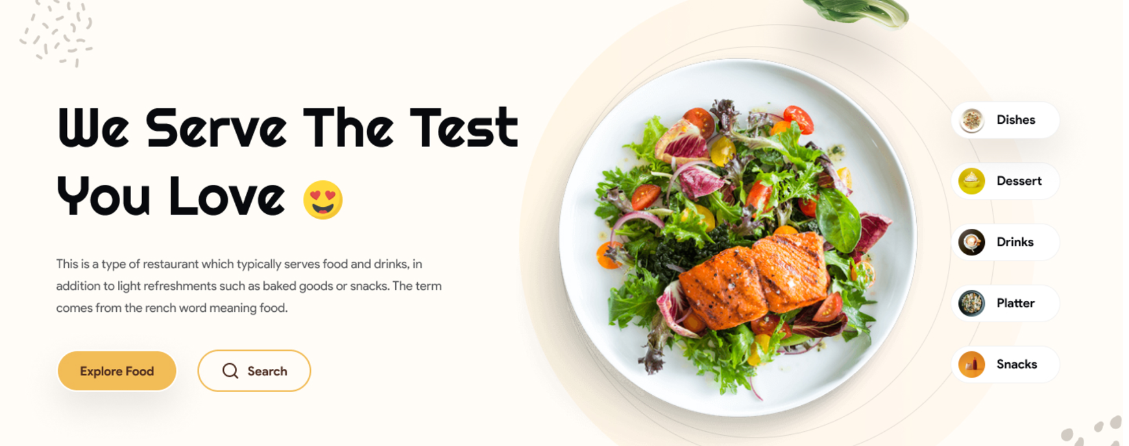

Best Seller

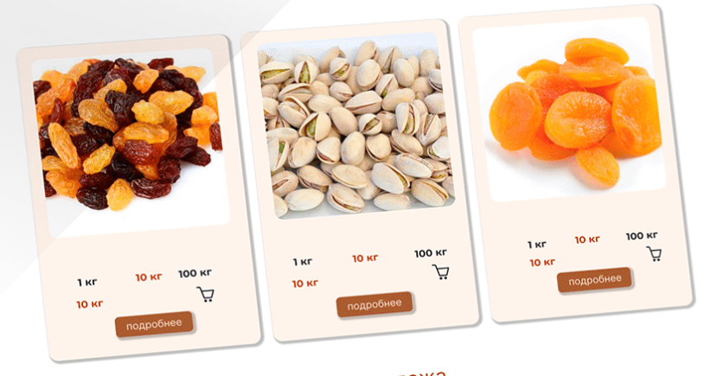

Work Section

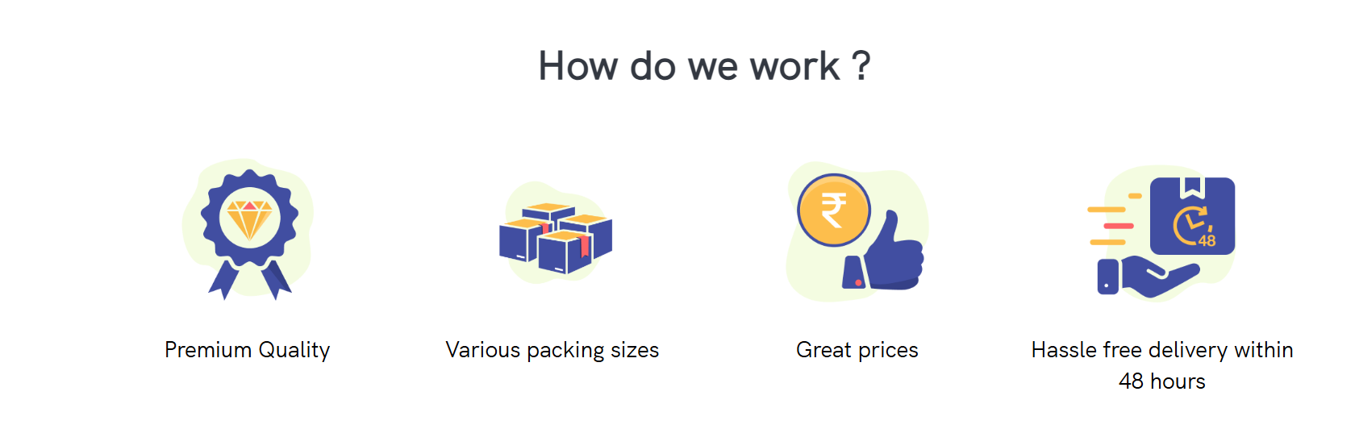

Best Featured Products

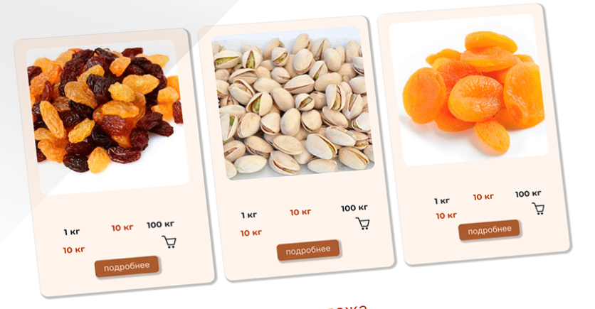

Text Section



Offers Sections

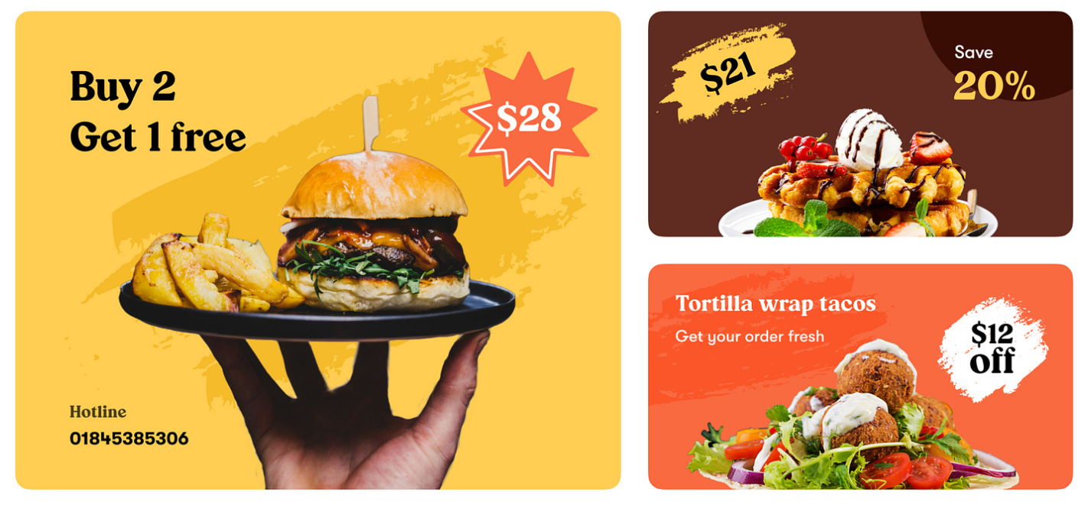

Blog Section

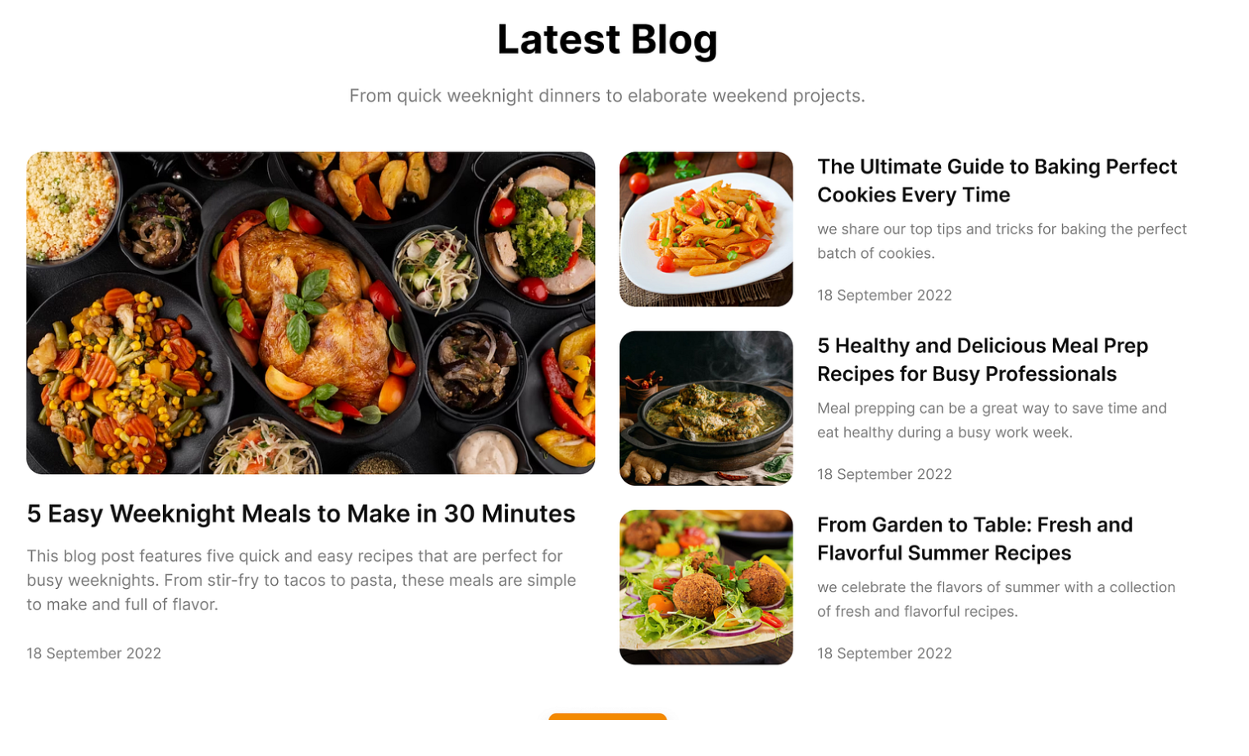

Location section

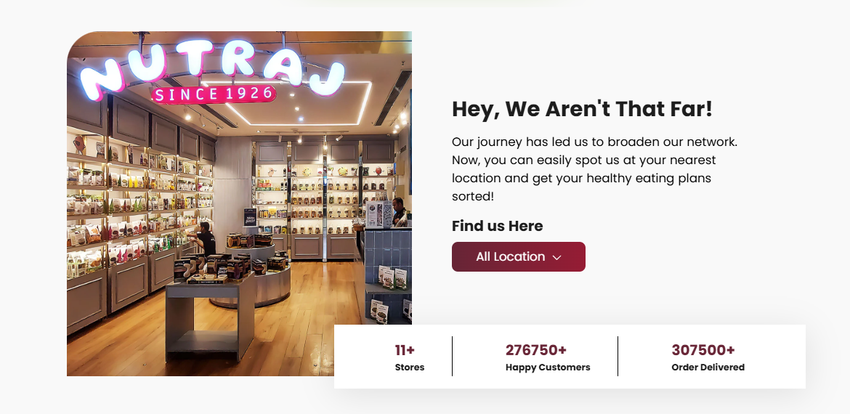

Testimonials

[Dribbble - Dribbble cover.png by Shubham Deep Gupta](https://dribbble.com/shots/17912414-Customer-Testimonial-Review-Web-Design/attachments/13090649?mode=media)

Subscribe Newsletter



Footers